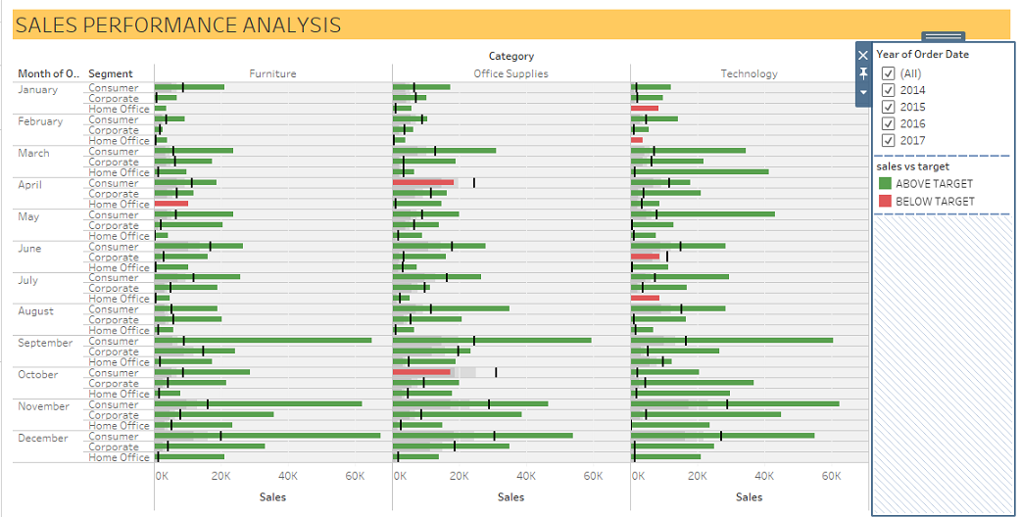

INSIGHTS:-

1. Considering the sum analysis for all the year at once, it can be seen that in the month of April under Product Category- Office Supplies and Segment Consumer, the target has been missed by approx. 28%., with target being 24,593 and sales being 18,400.93., whereas such a similar trend can be observed in the month of October also considering the average sales and target, the target has been missed by approx. 47%.

2. In the month of June under Corporate the sales for technology has underperformed by 20%, but reaching 80% is not a bad performance as all in all technology category has done all better sales throughout.

3. It can also be inferred from the bullet chart that in the last 4 months of every year all the three category have exceeded the target by a good margin, with technology and furniture leading office supplies in terms of achieving target.

4. While filtering data year over year it can be seen that in the last year the target data for many product categories has been missing which may skew the all over data a bit while taking the average target for all years as the sales for that year would positively contribute to overall sales. Thus giving a hallow effect of achieving more than target. Whereas once you go year over year you get a clear picture that there have been considerable instances where target have not been achieved.

5. While glancing through the data it can be inferred that improvement needs to be done for boosting sales in the office supply categories for all subsequent year. Furniture and Technology is doing comparatively better.

TABLEAU PUBLIC WORKBOOK LINK :- <https://public.tableau.com/shared/SHKGMTGK5?:display_count=y&:origin=viz_share_link>

SUBMITTED BY:

RAHUL RANJAN